Python code for controlling gripper - input angle (0 for open, 30 for close)

Gripper prototypes

| Versions | 1 | 2 | 3 | 4 |
| --- | --- | --- | --- | --- |
| CAD |  |  |  |  |
| Printed parts |  |  |  |  |
| Comments | Too small, gear teeth detail/resolution is insufficient | 2 Versions of this were printed, the first one had the wrong hole tolerances due to the resolution of 3D printed, joints were too stiff to move. This is a scaled up version of 1 | Sliding part kept getting jammed as the gripper arm kept slightly rotating  Tried filing down parts but still unsuccessful | Silicone bit between tip and main arm - limits amount of force applied to sample  Same mechanism as 1 and 2 |

Gecko adhesion:

Tried to cast ecoflex-30 onto diffraction grating sheet to achieve micro-grooves – failed, no extra adhesion achieved, holographic sheen also not achieved

-ordered in micro-pore track-etched membranes to cast silicone to create surface with small “hairs”

- got some gecko inspired glasses pad to prototype with for now

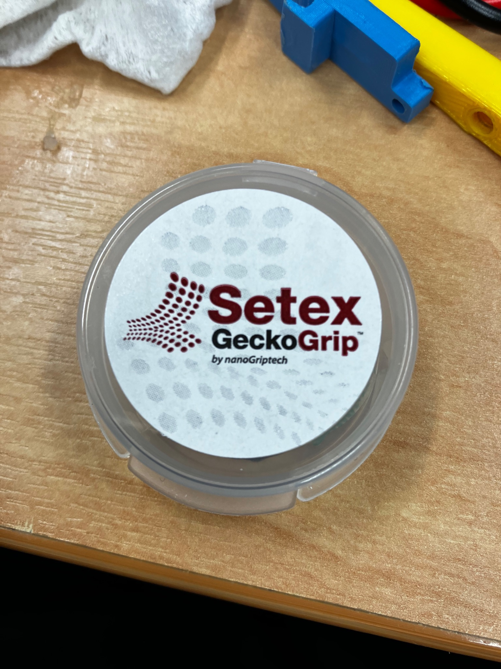

Strain sensor

Tried casting ecoflex-30 + conductive ink

* Failed, tried 40% carbon conductive ink by weight yet still not conductive, at this amount, silicone mixture started becoming too stiff. Carbon particles also started aggregating as silicone cured (all mixed by hand)

Tried casting ecoflex-30 + milled carbon fibre + graphite powder (mixed using high-speed mixer)

* Failed, tried mixing in as little carbon fibre and graphite powder as possible to achieve conductivity. Managed to achieve a conductivity in the order of 100M ohms plus. Once cured, mixture was extremely tough - not stretchable

Got some flexible pressure sensors which will be used later on as two methods above isn’t very promising

FEA analysis (model)

|  | still iterating through results (this is produced by 0.1N force in 2 directions at tip of gripper) |
| --- | --- |